# Windows RT: Windows on ARM

Windows RT: Windows on ARM 1

Introduction to Windows RT 2

Creating Windows RT Devices 3

Windows Desktop 4

Windows RT and Apps 5

App Details 5

Microsoft Office 15 6

Microsoft Office 15 App Details 6

Connected Standby 7

Comparing ARM with the x86 Architecture 7

Windows RT and Devices 8

Booting Windows RT 8

Feature Differences from Windows 8 11

Windows RT Q&A 12

#### Timing for this module

|  |  |
| --- | --- |
| Delivery Length: 60 Minutes | Additional Lab Time: No Lab |

#### Overview

At the same time that Microsoft releases Windows® 8, we will also be releasing a new family of Windows known as Windows RT. The experience and design of Windows RT is very similar to Windows 8, and many of the new enhancements and changes that have been introduced for Windows 8 will also be coming to Windows RT. The primary difference between Windows 8 and Windows RT is the underlying hardware architecture. Windows RT is the first version of Windows to support the ARM processor architecture, which is the architecture used primarily by smartphones and mobile-OS based tablets. Microsoft® Office 2013 will be included with Windows RT. Devices with Windows RT will include the Microsoft Office 15 apps Microsoft Word, Microsoft PowerPoint®, Microsoft Excel®, and Microsoft OneNote®.

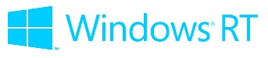

This module will provide additional information about Windows RT, including the differences between Windows RT and Windows 8 (which runs on the x86 architecture) and some of the key points you will need to understand in order to support this new family of Windows.

**Note:** At the time of this writing no Windows RT devices were available on the market, and we do not expect that you will have access to these devices during your training. The focus of this module is to provide an overview and background information on Windows RT, but due to the fact that we will be unable to utilize these devices during the training, hands-on activities and demos are not yet included.

## Introduction to Windows RT

**Windows RT is a new member of the Windows family that builds on the foundation of Windows.** Windows RT has a very high degree of commonality and very significant shared code with Windows 8, and will be developed for, sold, and supported as a part of the largest computing ecosystem in the world. Windows RT was created to enable a new class of computer with unique capabilities and form factors, supported by a new set of partners that expand the ecosystem of which Windows is part.

**Windows RT computer makers will be shipping at the same time as computers designed for Windows 8 on x86/64.** These computers will be built on new hardware platforms provided by ARM licensees like NVIDIA, Qualcomm, and Texas Instruments, with a common Windows RT OS foundation—all running the same Windows OS binaries, a unique approach for the industry. Computer manufacturers are hard at work on computers designed from the ground up to be great and exclusively for Windows RT.

**Windows Store apps in the Windows Store can be built to support both Windows RT and Windows 8 on x86/64.** Developers wishing to target Windows RT do so by writing applications for the Windows Runtime (WinRT, or the new Windows software framework for building Windows Store apps) using the new Microsoft Visual Studio® 11 tools in a variety of languages, including C#/VB/XAML and Jscript/HTML5. Native code targeting WinRT is also supported using C and C++, which can be targeted across architectures and distributed through the Windows Store.

**Windows RT includes the same Windows Store apps inbox that are included in Windows 8.** This includes apps like Mail, Calendar, People, and Bing, and the experience when using these Windows Store apps will be the same regardless of the architecture.

**Windows RT does not support running, emulating, or porting existing x86/64 desktop apps.** Code that uses only system or OS services from WinRT can be used within an app and distributed through the Windows Store for both Windows RT and x86/64. Consumers obtain all software, including device drivers, through the Windows Store and Windows Update.

**Windows RT includes desktop versions of the new Microsoft Word, Excel, PowerPoint, and OneNote.** These new Microsoft Office applications, part of the Microsoft Office 2013 Home and Student RT suite, have been significantly architected for both touch and minimized power/resource consumption, while also being fully-featured for consumers and providing complete document compatibility.

**Windows RT supports the Windows desktop experience including File Explorer, Microsoft Internet Explorer® 10 for the desktop, and most other intrinsic Windows desktop features.** These have been significantly architected for both touch and minimized power/resource consumption.

**With Windows RT you can look forward to integrated, end-to-end products—hardware, firmware and Windows RT software, all built from the ground up.** Building Windows RT has been an ongoing engineering effort involving Microsoft, ARM licensees, computer makers, and developers of components and peripherals. These efforts spanned a wide array of subsystems that have been newly created or substantially re-architected for Windows RT. Partners will provide Windows RT computers as integrated, end-to-end products that include hardware, firmware, and Windows RT software. Windows RT software will not be sold or distributed independent of a new Windows RT computer, just as you would expect existing ARM-based tablets and smartphones on the market today.

**Windows Update-based servicing.** For *all* platform code (OS, drivers, system and device firmware), each WOA system will be serviced through Windows Update (WU), from top to bottom. We’ve added support in WU for securely and robustly updating the system firmware on WOA systems, as well as driver targeting, which means that each device will get the drivers that have been verified to work best with it.

## Creating Windows RT Devices

Developing Windows RT begins as a partnership with companies that make ARM processors and package them together with the subsystems required to deliver the equivalent of a motherboard. Unlike the boards many are familiar with, you can think of a Windows RT board as a silicon package—a series of silicon layers bound together in an incredibly small form factor, called a *System on Chip* or *SoC*.

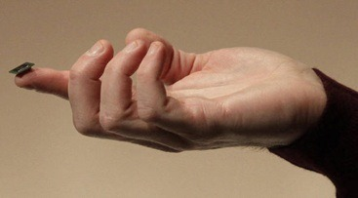

Figure 1: CES 2011 demonstration showing a System on Chip (SoC). (Julie Jacobson, Associated Press)

Each ARM licensee building these packages takes a different approach to selecting features, making product trade-offs, and designing the complete silicon package. These choices are what bring the diversity of different products built on ARM to the market. There is no single ARM experience, and as we have seen with other operating systems, even the same ARM CPU combined with different components, drivers, and software can yield different types or qualities of experiences. That is why from the start of the Windows RT project, we have partnered with three ARM licensees: NVIDIA, Qualcomm, and Texas Instruments. These partners have substantial experience with creating ARM-based products, and are responsible for many of these products on the market today, from tablets to smart phones to e-readers to embedded devices.

Each of these ARM licensees has been working with partners that will bring WOA computers to market. These computers have all been designed and manufactured expressly for WOA. From the chipset through the firmware and drivers, the work is optimized to be great for WOA. Partners are working hard on creative industrial designs and form factors that will include more than tablets.

A SoC package by itself is just the beginning. Delivering Windows RT computers is a partnership with computer manufacturers who bring their expertise in manufacturing, system engineering, and industrial design and combine that with the engineering work of ARM partners to develop a complete computer.

Microsoft’s role in this partnership is to deliver a Windows operating system that is tuned to this new type of hardware, new scenarios, and new engineering challenges. Our goal is to make sure that a reimagined Windows delivers a seamless experience from the chipset through firmware, through hardware, through the OS, through applications, and ultimately to the person interacting with the computer. This is a new level of involvement that brings with it a new level of engineering work across all of the parties involved.

WOA computers will be serviced only through Windows or Microsoft Update, and consumer apps will only come from the Windows Store, so you do not have to worry if a program will run because you are not downloading or installing from a DVD outside of the store experience. A WOA computer will feel like a consumer electronics device in terms of how it is used and managed. For example, as previously detailed, the new refresh and reset functionality will be available, and for WOA this provides the equivalent of a “clean install” or imaging.

## Windows Desktop

The availability of the Windows desktop is an important part of Windows RT. The desktop offers you a familiar place to interact with computers, particularly files, storage, and networking, as well as a range of peripherals. You can use File Explorer, for example, to connect to external storage devices, transfer and manage files from a network share, or use multiple displays, and do all of this with or without an attached keyboard and mouse. You’ll have access to both PC Settings in the new Windows UI and the desktop Control Panel should you need it. The desktop interface has also been refined for touch interaction with improved user-interface affordances.

At the same time, Windows RT (like Windows 8) is designed so that customers focused on Windows Store apps don’t need to spend time on the desktop. Availability of the desktop incurs no runtime overhead. It is just there should you need it, and is not loaded until it is accessed by the user. The availability of the desktop does not do anything to compromise system security, reliability over time, performance, or power consumption of a Windows RT computer. When a user signs into Windows RT, they are presented with the Start screen, and as long as the user only navigates to the Start Screen or a Windows Store app, the Windows desktop will not load or consume resources.

## Windows RT and Apps

App usage on Windows RT will be primarily focused on Windows Store apps. Windows RT will include ARM versions of the same Windows Store apps that are included with Windows 8. Windows RT users will have access to almost all of the same Windows Store apps in the Windows Store can be provided in versions for x86, x64, and ARM. (Some apps are written with web technologies that allow them to be marked as Neutral, which means they will run on all supported architectures.)

* A limited number of new inbox and desktop apps will be ported over to Windows RT, but third parties will be unable to create desktop apps.
* The only desktop apps that will be distributed for ARM are included inbox or will be distributed through Windows Update.
* These desktop apps must be signed by Microsoft, and Microsoft will not be releasing tools to aid in the creation of ARM desktop apps.

### App Details

* **Windows RT will not support any type of virtualization, emulating, porting or in any way running existing x86/64** **apps** - Supporting non-native apps runs counter to the goal of delivering a product that takes a modern approach to system reliability and predictability—by definition, existing code has not been optimized for the platform the way WOA has. If you need to run existing x86/64 software, then you will be best served with Windows 8 on x86/64.
  + The fact that Windows RT will not support any existing desktop software will be a key differentiator you will need to be aware of when supporting Windows RT vs. Windows 8.
    - No existing desktop software, third-party services, media codecs, browser add-ons, or support tools that are not already in the box will be supported in Windows RT.
    - The only software that you will be able to utilize to troubleshoot a customer issue will be software that is included as part of Windows RT or was separately downloaded through Windows Update.
* **A Windows RT computer will continue to perform well over time** - Performance quality is maintained as apps are isolated from the system and each other, and you will remain in control of what additional software is running on your behalf, all while letting the capabilities of diverse hardware shine through.
* **App compat functionality removed -** Many features in Windows 8 that we include to enable backwards compatibility with older apps have been removed from Windows RT since running desktop apps is not possible (other than the apps included with the device or provided through Windows Update). There is no concept of legacy apps for Windows RT, so removing these application compatibility affordances reduces the overall footprint of the OS and optimizes battery life and performance.

## Microsoft Office 15

Within the Windows desktop,Windows RT includes desktop versions of Microsoft Office 15 apps, including the new Word, Excel, PowerPoint, and OneNote. The new Microsoft Office apps for Windows RT have been significantly architected for both touch and minimized power/resource consumption. These are not simply recompilations or ports, but are instead a significant reworking of the products with a complete and consistent user experience and fidelity with their new x86/64 counterparts. The UI and features included for the ARM versions of PowerPoint, Excel, Word, and OneNote will match their x86 counterparts.

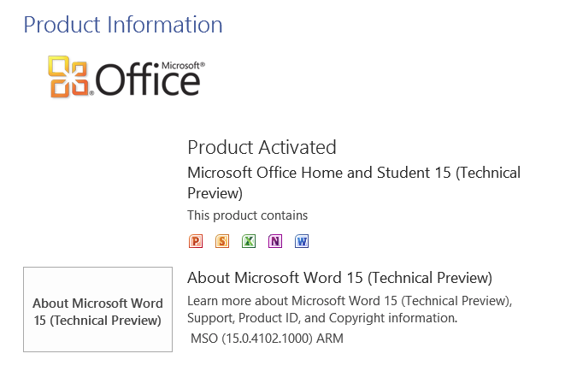

Figure 2: Microsoft Office activation

### Microsoft Office 15 App Details

* Because Microsoft Office 15 will be releasing after Windows RT is launched, when the Windows RT devices are first released they will include a Preview version of Microsoft Office 15. Once the final version of Microsoft Office 15 is available, Windows RT users will be able to update to the final version of Microsoft Office 15 through Microsoft Update. Additional information about this update process will be provided closer to the time that the update is available.
* Support for Microsoft Office 15 apps will be provided by the Microsoft Office support team, and information about the new features and changes that are being introduced for this release of Microsoft Office will be included in the Microsoft Office 15 app support training.
* No mechanism for uninstalling or reinstalling Microsoft Office 15 apps will be provided. There is no entry in “Turn Windows Features On or Off” or in the Programs Control Panel. Reinstalling Microsoft Office will require reinstalling Windows RT using the Push Button Reset functionality to “Reset your PC.”

## Connected Standby

One of the new aspects of Windows RT you will notice is that you don’t need to turn off a Windows RT computer. Windows RT computers will not have the traditional hibernate and sleep options with which we are familiar. Instead, Windows RT computers operate in the newly designed Connected Standby power mode, similar to the way you use a mobile phone today.

* When the screen is on, you have access to the full power and capabilities of the Windows RT computer.
* When the screen goes dark (by pressing the power button or timer), the computer enters a new, very low-power mode that enables the battery to last for weeks.
* All along, however, the system dynamically adjusts power consumption and is always on the lookout for opportunities to reduce power to unused parts of the system.

For end-users, a unique capability of Windows RT is that you are in control of what programs have access to background execution so that those apps are always connected, and information like new mail is always up to date. Connected Standby permeates the engineering for Windows RT computers from the hardware through the firmware, OS, WinRT platform, and apps. Connected Standby won’t be limited to the ARM architecture and we are actively working on these capabilities for x86/64 SoC products as well.

## Comparing ARM with the x86 Architecture

Today, we are familiar with a computer experience where x86-based Windows computers that follow a set of technical specifications allow one version of Windows to install and run on a wide variety of computers. This openness is the hallmark of the computer revolution and represents the collective work of the industry since about 1980. Absolutely nothing about this approach will change for Windows 8. Windows 8 will run on every Windows 7 logo computer, and will run all of the existing software and peripherals designed for and supported on Windows 7 (when supported on Windows 8 by the manufacturer, of course).

The approach taken by ARM Holdings, the licensor of ARM products is, by design, not standardized in this manner—each device from each manufacturer is unique and the software that runs on that device is unique. There is a standard instruction set and CPU architecture, one that is always improving (for example, adding 64-bit support and multiple cores), but many of the connections between the CPU and other components are specific to the implementation each licensee brings to the ARM platform.

* ARM device implementations across different smartphone and tablet OS platforms can be similar, but this is not relevant for users of those devices.
* End-users are technically restricted from installing a different OS (or OS version) on a device or extending the OS, so this is generally not possible, and rarely supported by the device maker.
* Device makers work with ARM partners to create a device that is strictly paired with a specific set of software (and sometimes vice versa) and consumers purchase this complete package.

The cross-partner, integrated engineering of these embedded devices is significant. In these ways, this is all quite different than the Windows on x86/64 world. At the same time, WOA will be consistent in capabilities, experience, and baseline performance across all devices.

## Windows RT and Devices

Windows RT devices will be conceptually different from a device management and driver perspective. Unlike computers that can be a collection of hardware both embedded in the motherboard and plugged into expansion slots that can be reconfigured, tweaked, and upgraded, an ARM device is a fixed device.

* The internal hardware is fixed, meaning that the processor, memory, drives, wireless radio, and display chip will never be changed in the life of the device.
* ARM devices have no expansion slots, so there is not a concept of PCI, AGP, or PCI Express slots for these devices.
* This means that Windows no longer has to maintain a driver store to account for any hardware that might ever be plugged in during the life of the device. This reduces the on disk footprint of Windows RT by hundreds of megabytes.
* Windows RT employs a class driver model for most peripheral devices. This means basic support for most common devices is provided inbox. Co-installers for device drivers are not supported in Windows RT, which on x86-based computers is what driver manufactures use to install companion software for their device, such as a utility for configuring your trackpad. Device manufacturers now have the ability to create Device Companion Apps that are Windows Store apps published in the Windows Store, and these apps can be automatically downloaded.

This section will walk through many of the important hardware changes that you should be aware of for Windows RT devices. Some of these will affect the way that you perform troubleshooting, and others are outlined with the goal of helping you conceptually understand the new Windows RT platform from a hardware perspective.

### Booting Windows RT

The Windows RT boot environment utilizes many of the same concepts you will find in a Windows 8 computer. The beginning of the boot experience starts with the system firmware.

* **UEFI firmware** is the lowest layer of a WOA system and provides consistent services for loading the OS. For WOA, we created firmware to bootstrap the system that we handed off to our partners. WOA systems also include a firmware-based **TPM** for trusted boot and storage encryption. Using the TPM, for example, we’ve implemented trusted boot which verifies that the system hasn’t been tampered with by malware.
  + While Windows 8 computers will continue to support both BIOS and UEFI based systems, all Windows RT computers will use UEFI. Similarly, the TPM that is optional for Windows 8 computers will be required for all Windows RT computers.

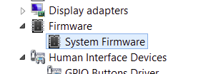

Figure 3: System firmware

* **ACPI firmware** is used for plug and play enumeration of devices in the platform during boot, and is also responsible for power management of devices outside the SoC (such as sensors, touch controller, etc.). Over the years, the computer has standardized with plug-and-play busses and ACPI, so that operating system software and drivers can “walk the tree” to find everything in a computer. With SoC embedded designs, there is no “tree” or ability to discover what is connected to a SoC, or even how the SoC is connected. To address this, Windows RT uses a separate mechanism to which describes the configuration of the system with tables, so software can simply read the table and configure the system.

From the firmware, the system can then load the boot manager, boot loader, and, in turn, the kernel, HAL, and boot device drivers.

* The **Windows Hardware Abstraction Layer** (HAL) supports variations in core system resources (timers, DMA, interrupt controllers). Windows was designed from the beginning to support multiple instruction set architectures (ISA), and the HAL is key to adapting to different system architectures that often come with a new ISA. By abstracting the hardware layers, the OS itself doesn’t have to be modified to accommodate a new SoC for core system resources.

#### Devices and Busses

In order to load device drivers and continue Windows boot, Windows RT includes several new drivers for new types of low-power busses, plus device drivers that support connections to those busses. Standardized protocols and class drivers are used extensively in Windows RT.

Our first example below is the HID over I2C driver which we use for touch controllers and many sensors, another is the class driver for USB connected mobile broadband radios. Windows includes class drivers for many categories of devices, some of which you experience when you plug in USB devices such as flash drives, mice, or keyboards.

* Low-power serial busses such as **I2C / UART** will be normal on ARM computers and less common on x86 computers. These busses generally have a lower data transfer rate, but also use very little power, in some cases 10x less. Support for these busses is key to reducing the overall power use of WOA and extending battery life. Collectively, we call these busses **Simple Peripheral Busses (SPBs)** and we’ve developed new interfaces in WOA for them.
* **SD I/O** allows you to connect low-power Wi-Fi radios. Radios in current computers are connected via USB or PCI-E. We added SD I/O support to preserve high data rates (100 MB/s) while still improving battery life. Wi-Fi support on WOA also allows efficient offloading to maintain connections in connected standby while using very little power.
* **Embedded Multimedia Card** storage (eMMC) is a *de facto* standard for storage on ARM devices (since most do not support SATA). In addition to supporting eMMC, we made several OS performance optimizations to reduce and coalesce storage I/O, resulting in fewer reads and writes to storage.
* The **General Purpose I/O** (GPIO) driver supports connecting buttons, interrupts or other I/O to the ARM processor.

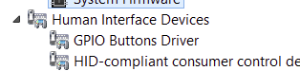

Figure 4: GPIO driver

* In addition to the GPIO driver, there’s also a **button driver** for the Windows, power, and volume buttons. Buttons aren’t standard on ARM devices. Each system requires a specific driver for all hardware buttons.
* We built a **new power framework** for managing SoC-wide power, total platform power, and the connected standby on/off usage model.

Once the firmware, HAL, boot services, boot devices, and busses were up and running, Windows RT is ready to start the rest of the system and get to the Sign-in screen.

* ARM SoCs for WOA have **DirectX capable GPUs** (DX) for accelerated graphics which is essential for delivering a responsive user experience. For each WOA target, the ARM partner has created a DX-compatible graphics driver.
* WOA computers use hardware support for offloading specific work from the main processor to **integrated hardware subsystems**. This improves performance and battery life.
  + For example, while watching a movie, the processing is done with multimedia offload (to a dedicated processor for example), and all other processing is minimized. Since the multimedia offload is optimized for playback, you can watch several movies without running out of battery or the computer could be designed to be even thinner and lighter.
  + Another example is if you’re working on a document and watching a movie at the same time, the movie is running on the offload hardware, which helps the overall system responsiveness.
  + WOA takes advantage of several types of offloads including multimedia encode and decode as well as security offload for Bitlocker and EAS. This type of engineering also applies to x86/64, which also support offloading, and was introduced in Windows 7.

## Feature Differences from Windows 8

From a feature perspective, you can think of Windows RT as a subset of Windows 8, meaning that all of the features included with Windows RT will also exist in Windows 8, though Windows 8 includes additional features beyond what is included in Windows RT.

**Note:** While Microsoft Office 2013 will be included with Windows RT, it is not considered to be part of the OS.

As a result, not all of the features from Windows 8 will be included with Windows RT. The following is a list of some of the key items that are not included with Windows RT that you might receive questions about.

* IEEE1394 (Firewire) support
* The Add Hardware Wizard, Add Network Printer Wizard, and Add Printer Driver Wizard
* **All video decoders other than WMV9/VC-1, H.264 and MPEG4 Pt.2**
* Complete computer backup
* File and Folder Backup (now called “Windows 7 File Recovery” in Windows 8)
* **Device Manager**
* Domain Join support
* Hibernate
* DVD Maker
* DVD playback support
* Fax support
* Offline Files
* Hyper-V™
* **Support for hosting files shares** (Accessing file shares is still supported)
* Memory Diagnostic
* Recovery Image Management Utility (**Recimg.exe**)
* **Remote Desktop**
* **Safe Mode**
* **Startup apps support**
* Sidebar/Gadgets
* SideShow®
* **Silverlight® 5**
* Sound Recorder
* Sync Center
* **System Restore**
* **Windows Media® Player**
* **Windows Media Center**
* WinSAT\Windows Experience Index
* Windows Media Player Network Sharing Service/Media Library Sharing support
* WordPad

Additionally, a few other changes have been implemented for existing Windows features. Some examples are shown below:

* It is not possible to disable Windows Defender, or to turn off the Real Time Protection functionality.
* It is not possible to disable Windows Firewall, or to stop any of the related services.
* Windows Update will be configured to automatically download and install important and recommended updates during Windows Welcome. Changing any of these settings is not possible in Windows RT.

## Windows RT Q&A

#### How do I perform a repair install or clean install of Windows RT?

Windows RT does not have the concept of traditional Windows Setup like we see in the x86 versions of Windows. If you need to reinstall Windows or reset the computer to its original state, you can use the new Push Button Reset functionality to either Refresh or Reset your PC.

#### Is it possible to run my existing desktop software on my new Windows RT computer?

Outside of Windows Store apps and desktop apps included inbox or distributed through Windows Update, no existing desktop software will run on a Windows RT computer. For example, this includes existing computer games, apps that integrate into the system and install additional services or drivers, any browser add-ons, troubleshooting utilities, driver updates or any other software that is not distributed through the Windows Store, Windows Update, or already included with Windows RT.

This will be a key point you should be aware of when supporting Windows RT devices. Tools that you may have used in the past to fix customer issues will no longer work if they are not inbox tools. While this may make it more difficult to troubleshoot certain classes of issues, in many cases it will make support much simpler. You no longer have to worry about misbehaving software loading on startup or integrating into the system somehow and slowing it down. The only time that a user will be able to have an experience that uses any third-party software will be with a Windows Store app or through a web page. This should dramatically improve the performance and stability of the computer, and reduce the number of issues we see where the user experience degrades over time.

#### How can I tell if a computer is running Windows RT?

Two easy methods for determining if a computer is running Windows RT are shown below.

* Open System Properties, and you will see a Windows RT logo. The system type will also show **ARM-based processor**.

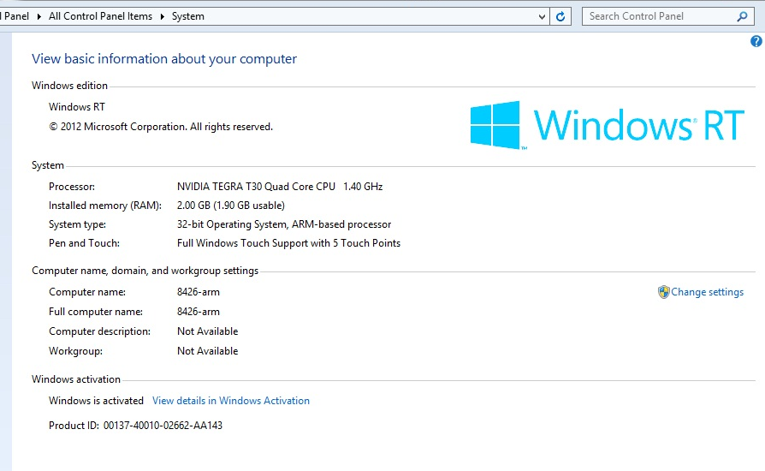

Figure 5: Windows RT, System Properties

Open Winver and you will see a Windows RT logo.

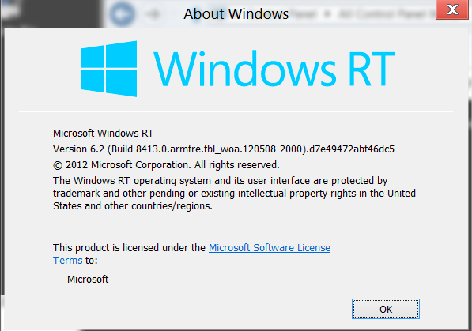

Figure 6: Windows RT, Winver

#### Will Windows RT computers only use the tablet/slate form factor? Won’t all tablets be running Windows RT?

Both Windows 8 and Windows RT computers will be distributed in a variety of form factors, and both Windows 8 and Windows RT can be used in tablets, laptops, convertibles, desktops, and all-in-one computers. Looking at the form factor alone will not be enough to determine whether the computer is ARM- or x86-based.